**Guide for getting your WhatsApp messages**

Minimum requirements:

* Access to a phone that has the WhatsApp app installed and at least one active group or conversation.

Step 1: Open WhatsApp.

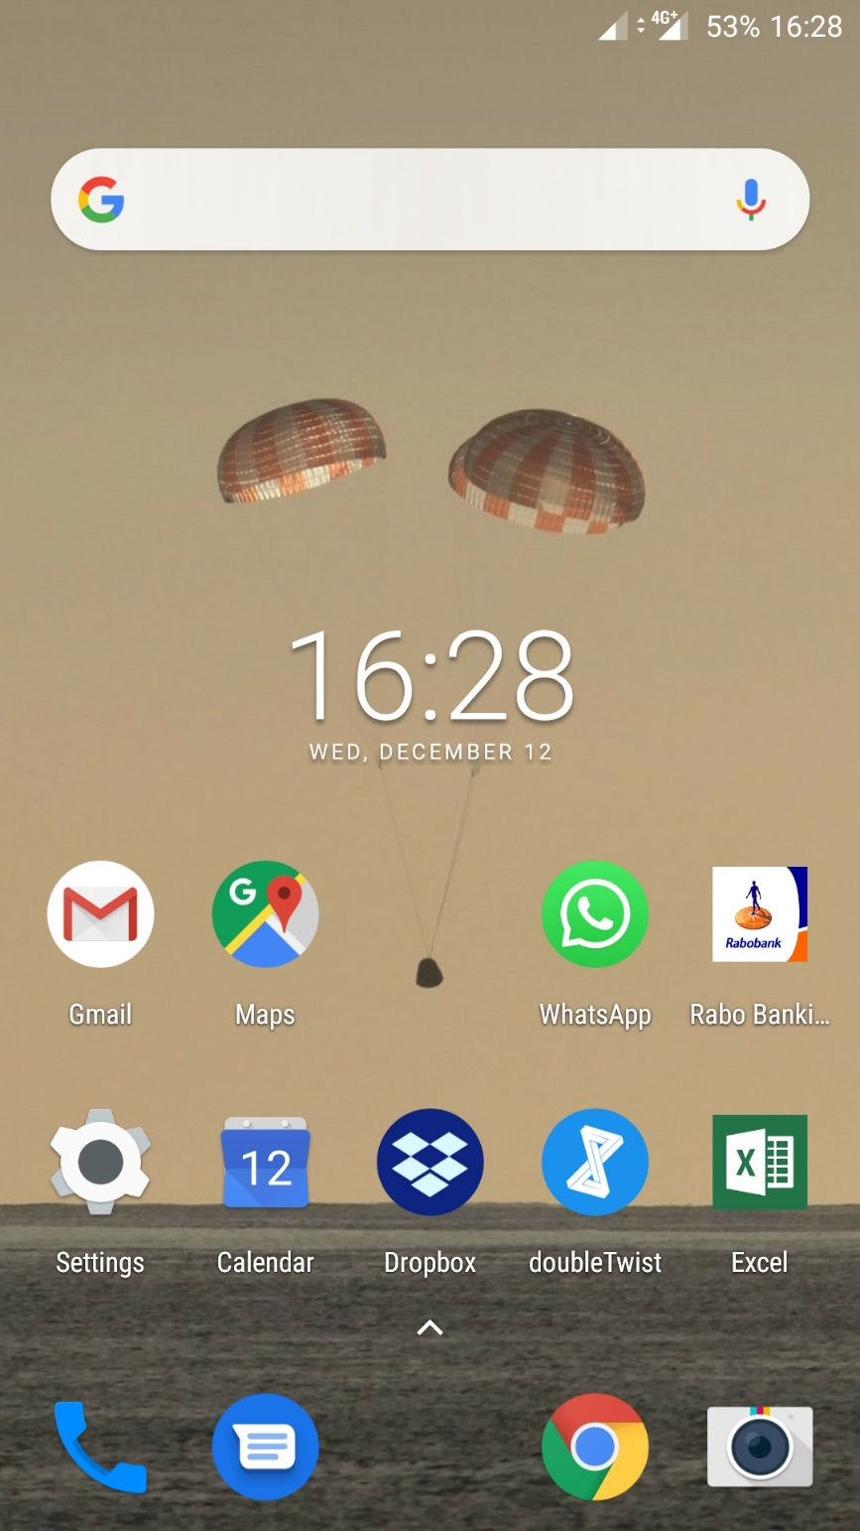

Step 2: Open the chat you want to export.

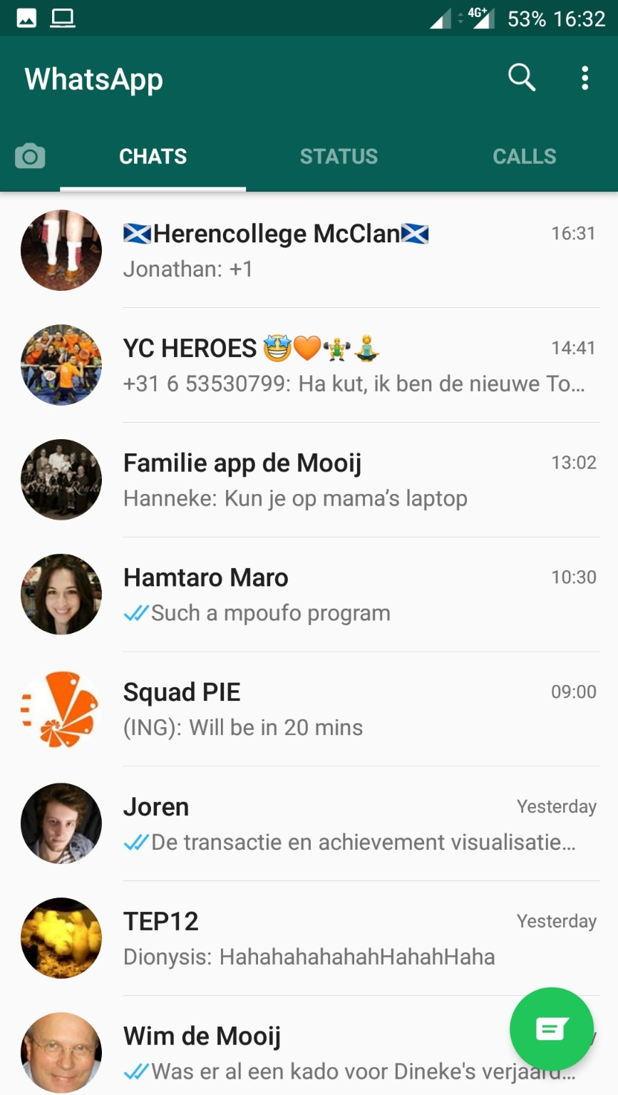

Step 3: Press the vertical ellipsis to open the menu:



Step 4: Press “More”:

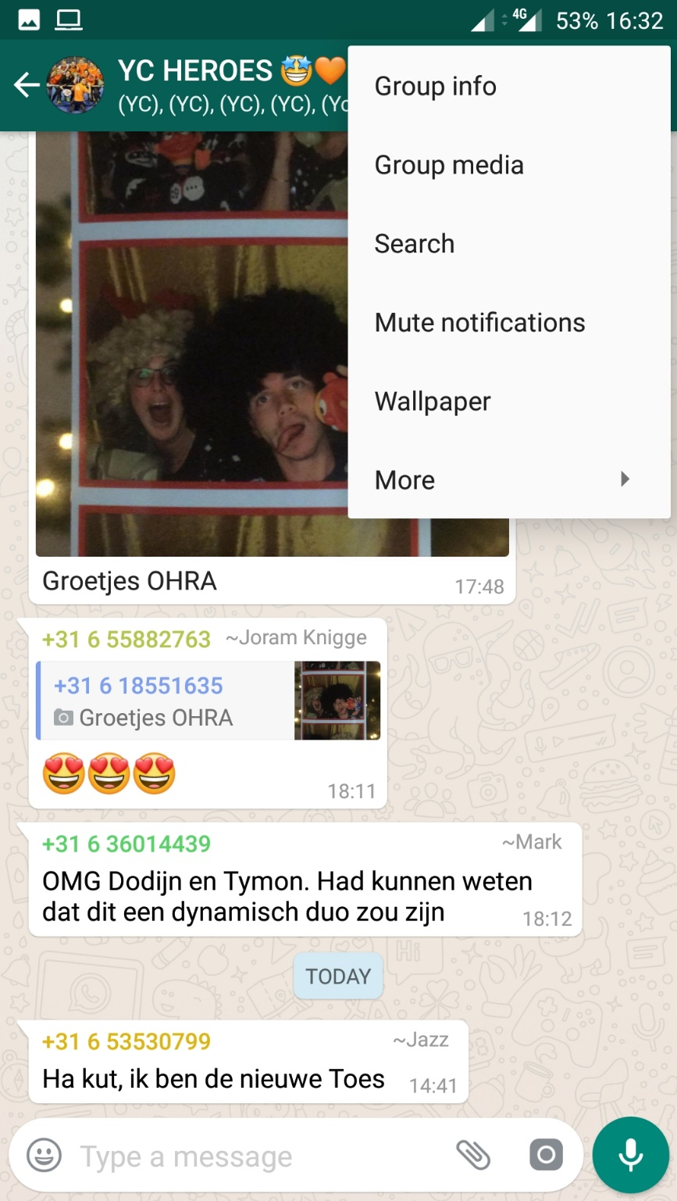

Step 5: Press “Export chat”:

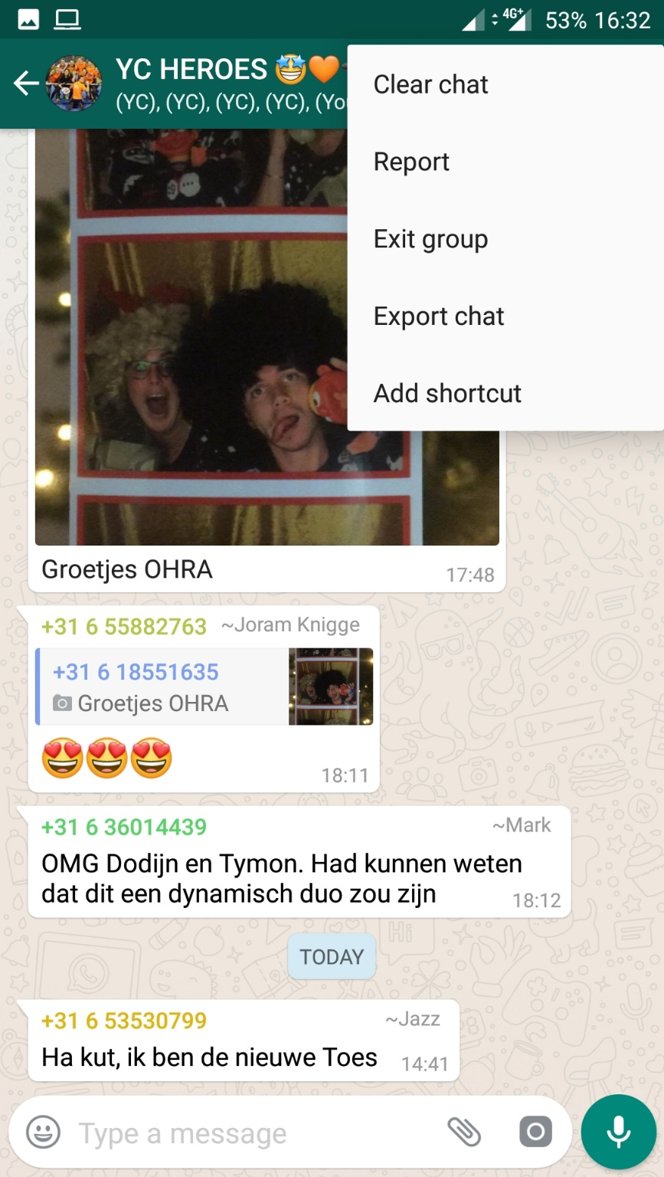

Step 6: Press “WITHOUT MEDIA”:

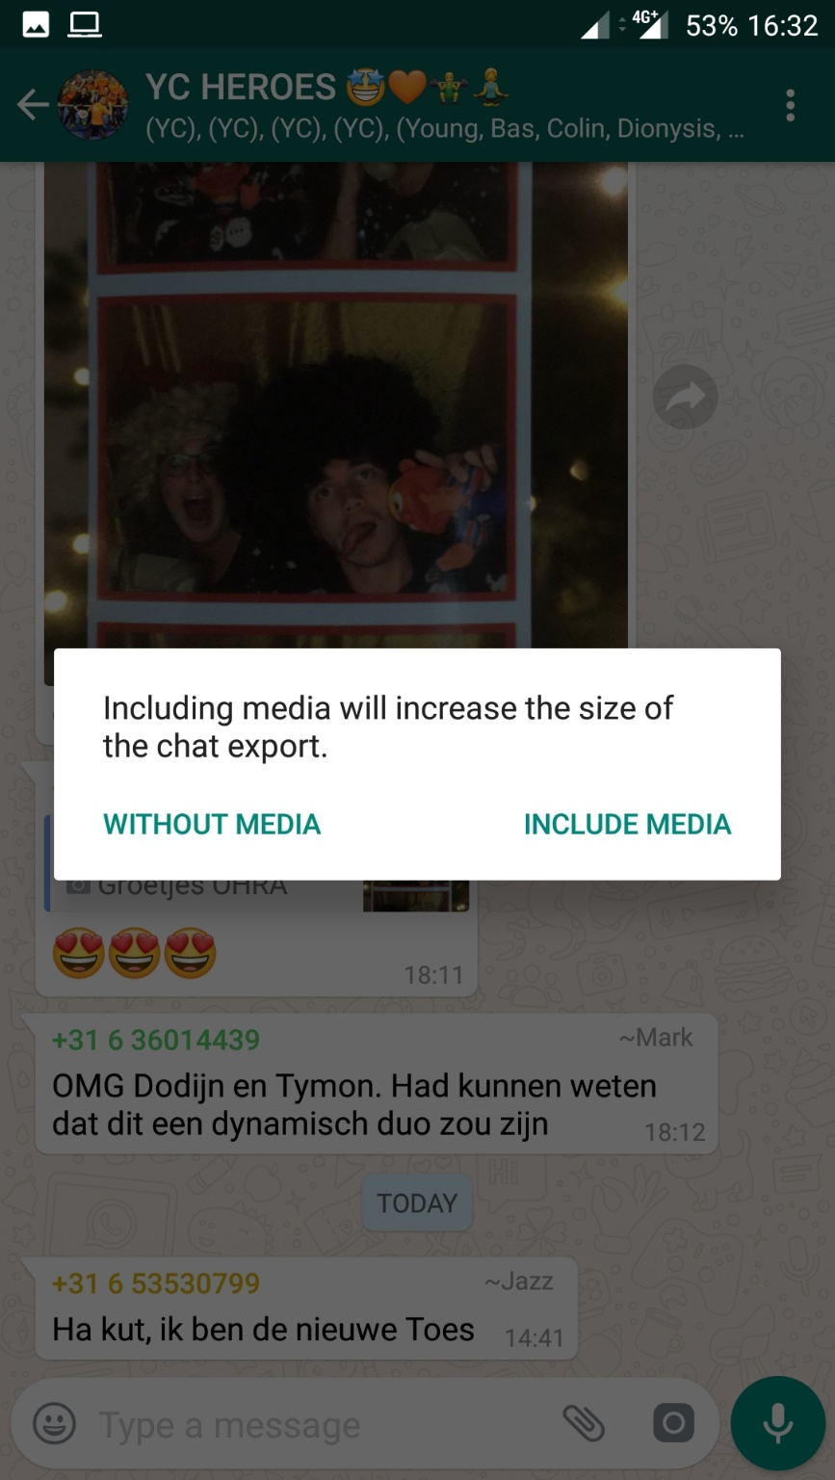

Step 7: Press “Gmail”:

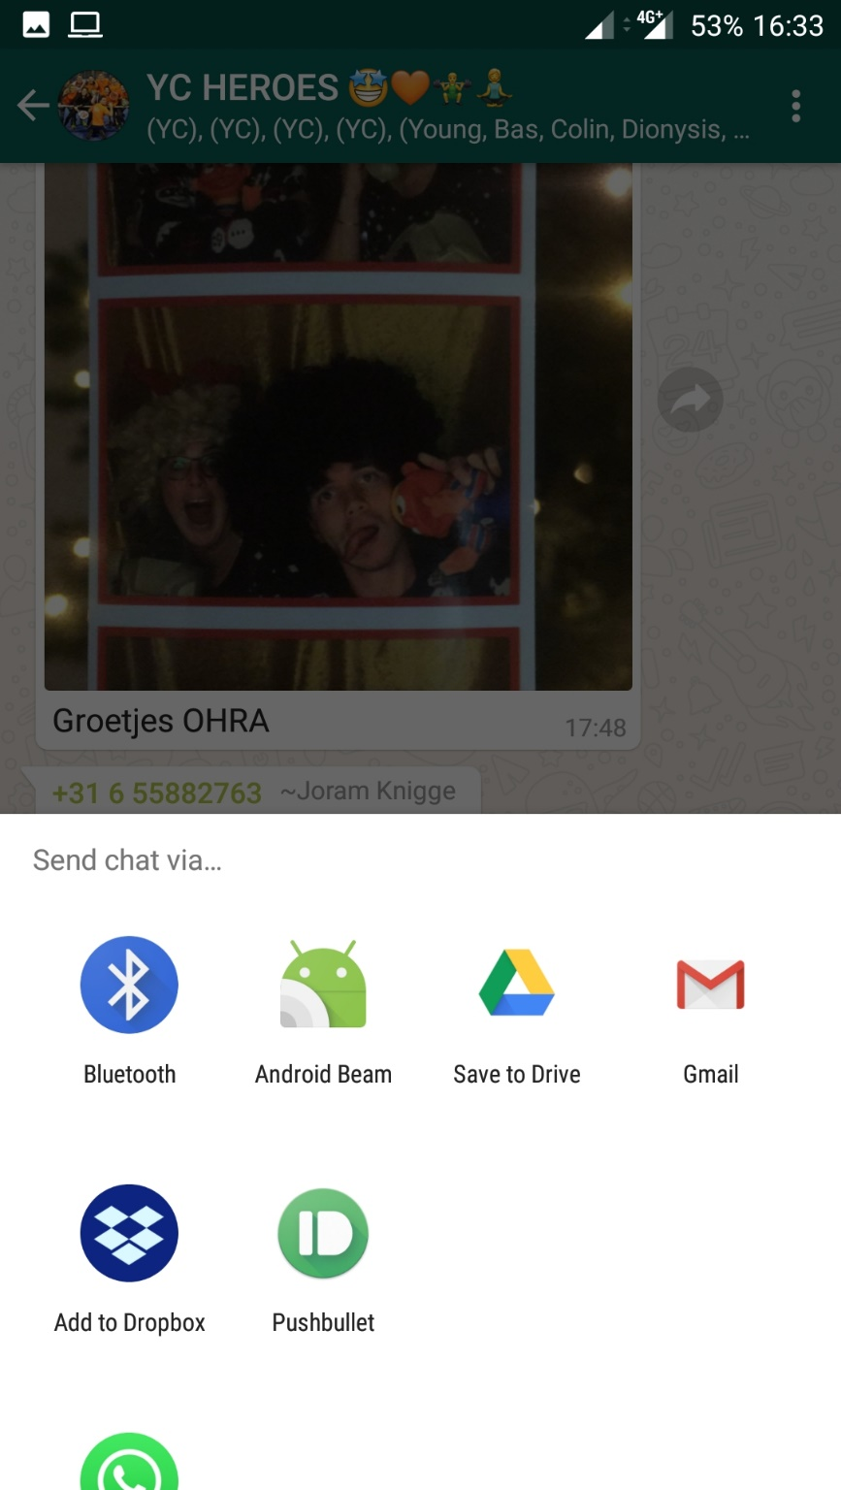

Step 8: Enter your own email address and send:

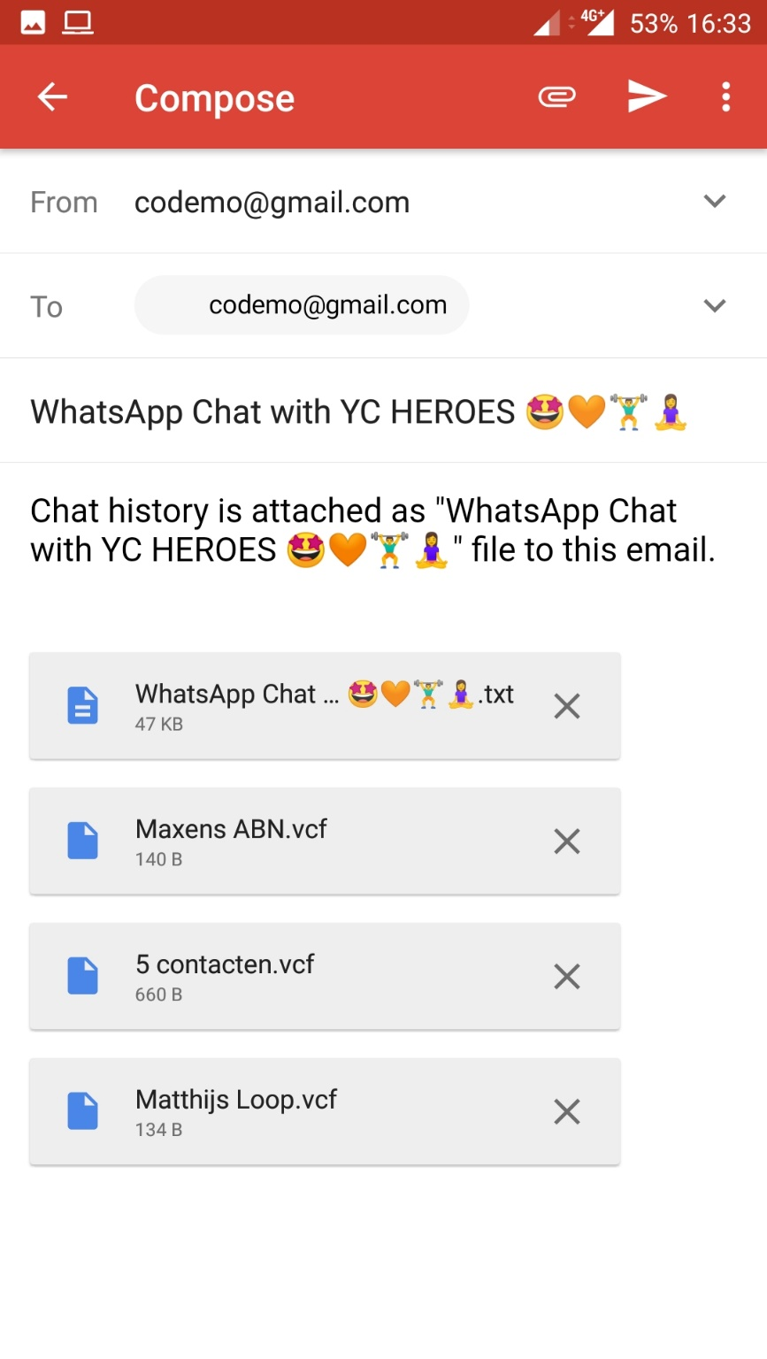

**2**

**1**